# **Ansible lab set**

* Create two instances with amazon linux kernel 6.12(give names ansible-server and host-server)
* Connect two instances

Execute following commands on ansible server 👇

sudo yum update -y

sudo dnf update -y

sudo dnf install -y ansible

sudo curl -o /etc/ansible/ansible.cfg <https://raw.githubusercontent.com/ansible/ansible/stable-2.15/examples/ansible.cfg>

ansible --version

cd /etc/ansible



# open ansible ansible.cfg and add below lines inside the file

[defaults]

inventory = /etc/ansible/hosts

host_key_checking = False

retry_files_enabled = False

sudo_user = root

vi ansible.cfg

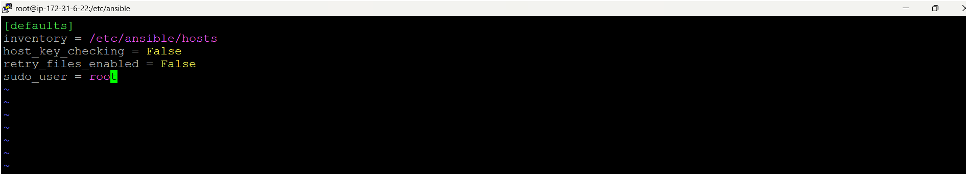

# create a file named hosts after open hosts file and add webservers and add your target machine pvt ip add

vi hosts

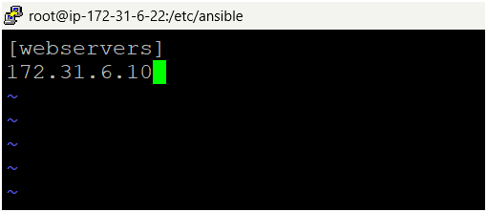

* Come to home directory

cd /home/ec2-user

* Create one user for ansible

useradd ansible

* Set a password for this user

passwd ansible

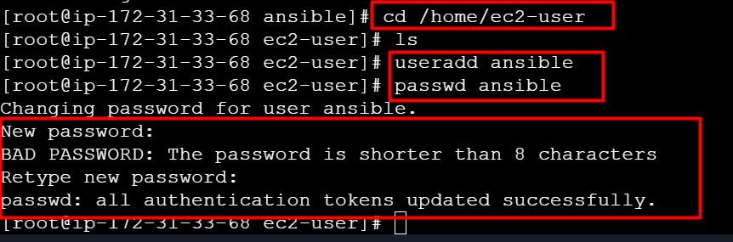

* Become as a ansible user

su - ansible

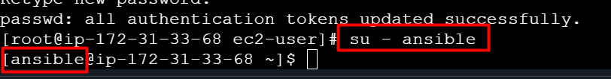

* Next you need to provide sudo privileges to ansible user (exit from the ansible user)



* Open visudo file

visudo

add this command under Root line ansible ALL=(ALL) NOPASSWD: ALL

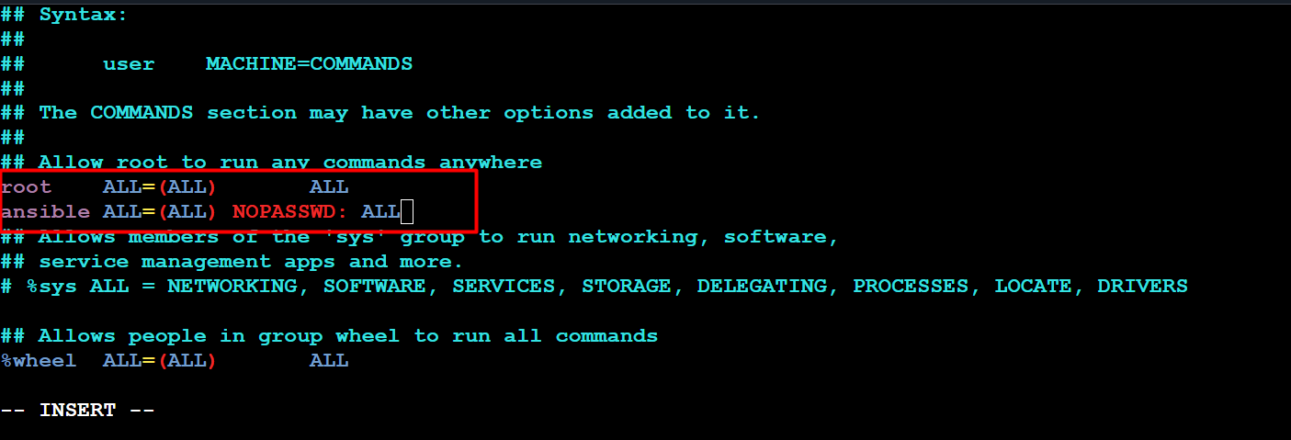

* Now create one ansible user on host-server/target machine as same as ansible-server and give same password here.
* Open visudo file and give sudo privileges to ansible user

visudo

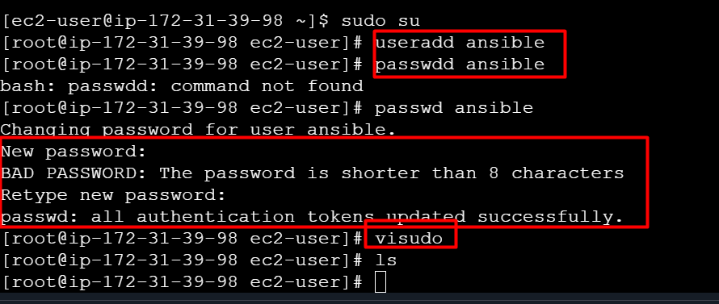

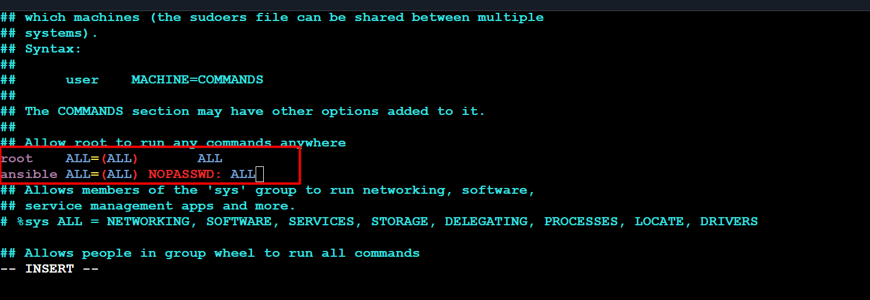

* We have to establish connection between ansible server and host server, follow the below steps on ansible server
* Open file /etc/ssh/sshd_config

vi /etc/ssh/sshd_config

* Uncomment for PermitRootLogin prohibit-passwd but remove prohibit-password replace with yes and find out this line passwordAuthentication no but remove no replace with yes

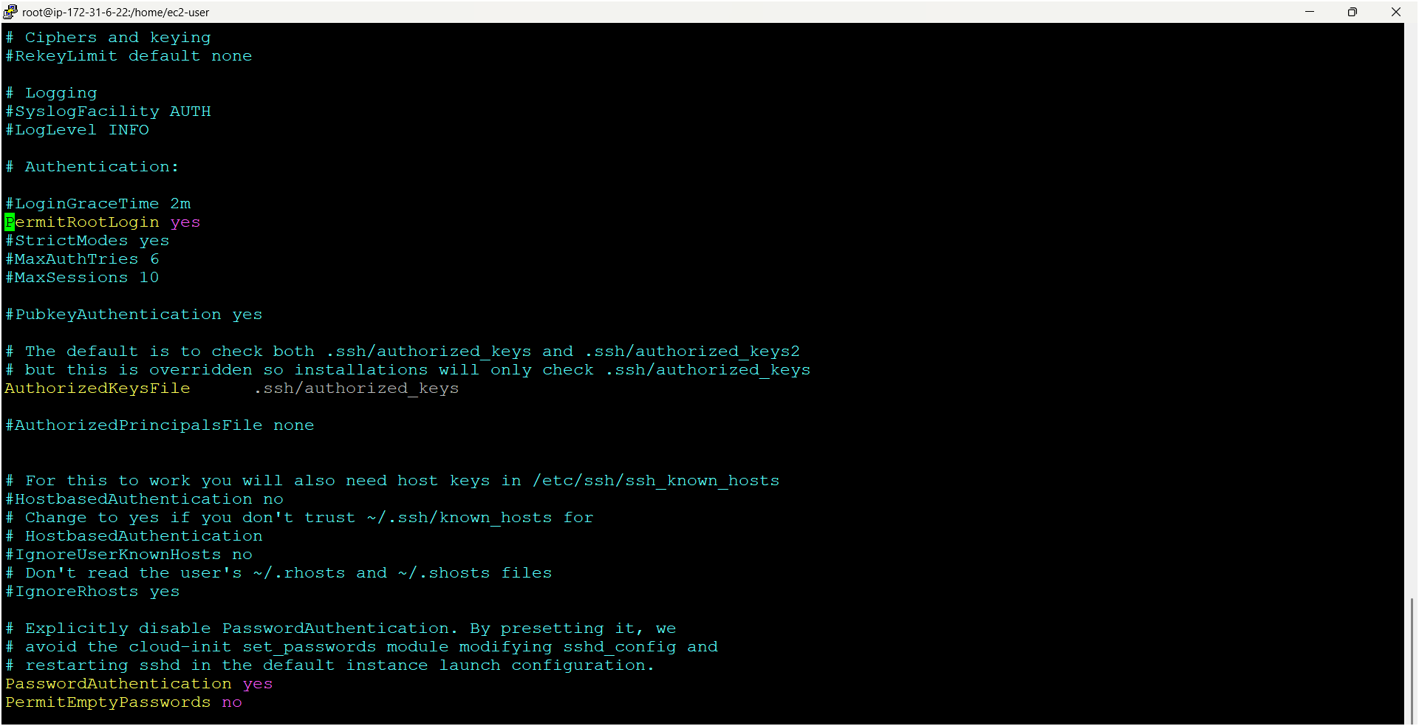



* Same steps do for host-server also ☝️
* vi /etc/ssh/sshd_config
* Uncomment for PermitRootLogin prohibit-passwd but remove prohibit-password replace with yes and find out this line passwordAuthentication no but remove no replace with yes



* Now you need to check connection between ansible-server and host-server
* Next you need to restart servers both ansible-server and host-server

service sshd restart (on both servers)

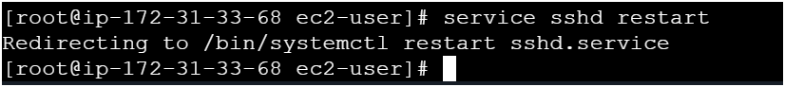

* Now become as a ansible user on ansible-server
* Next Copy pvt ip address of host-server
* Go to ansible server use below command

ssh <pvt-ip-add> (host-server pvt ip add)

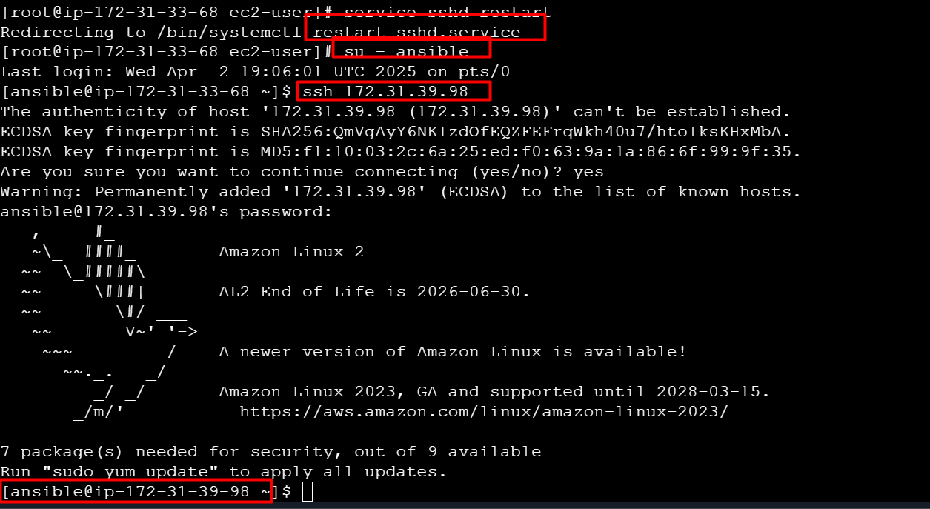

* Now its connected to your host-server (check pvt ip add of host-server)☝️
* Next exit from the host-server



* Now you need to make connection between servers without providing password and follow below commands on ansible-server 👇 (run commands as an ansible user only)

ssh-keygen (it will generate two types keys one is public key & pvt key)

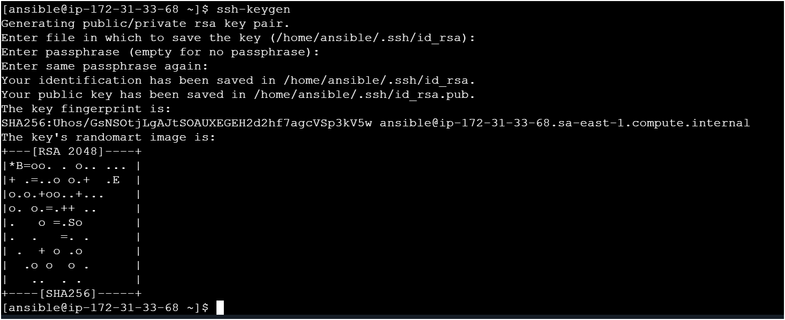

* Now look for key using

ls -la

cd ..ssh

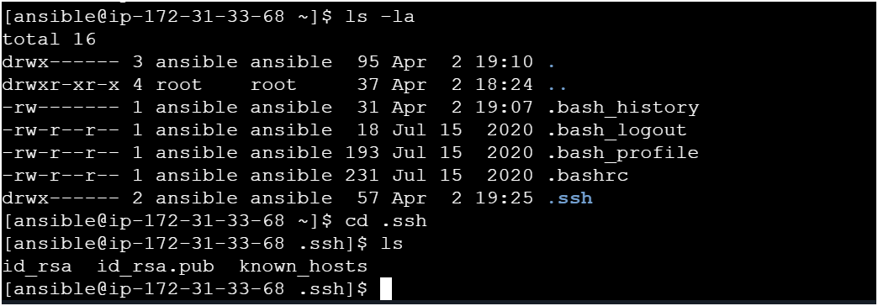

* How to copy public key to host-server from ansible-server 👇

ssh-copy-id ansible@pvt-ip-add-of-host-server and it will ask passwd provide ansible user passwd only 👇

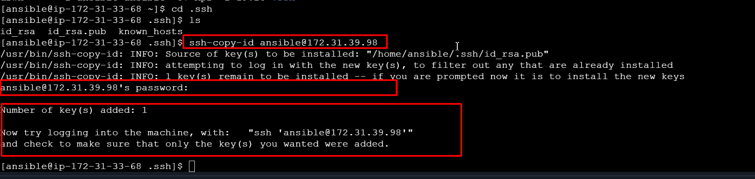

* Now do cross check by login to host-server from ansible-server without providing any passwd using below command 👇

ssh <pvt-ip-add> (host-server-pvt-ip-add)

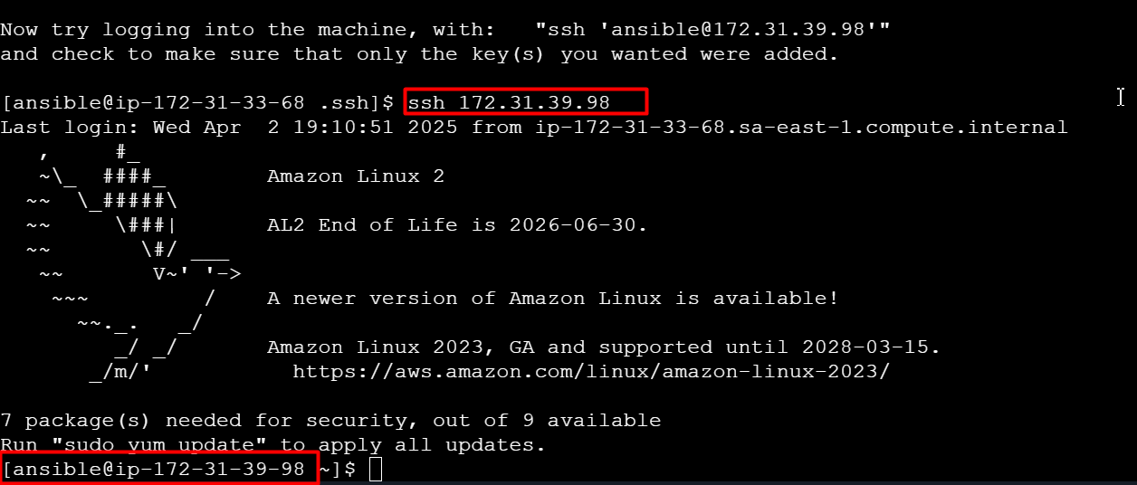

* Now you can check on host-server whether key is copied or not 👇

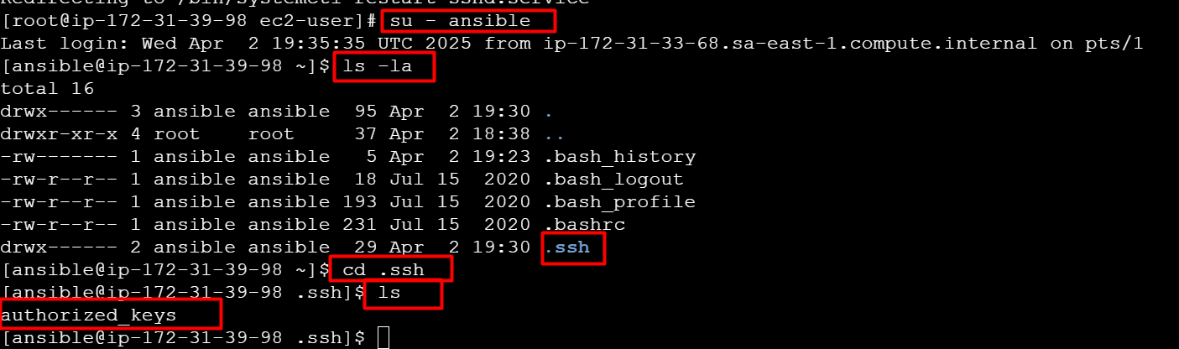

* Also you can check the connection from ansible-server using below command

ansible webservers -a “ls”

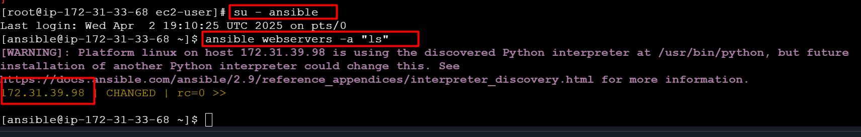

**Lab set was done**